# THE NEW PARENT'S GUIDE



**Congratulations on your new baby!**

You will find so many books, leaflets and websites full of advice about caring for your newborn baby. As your GP practice, you will be seeing us more frequently over the next year or so, therefore we thought it might be useful to put together a quick guide more specific to the services that we offer at Trevelyan House.

During the first few months, babies can have many problems from dry skin to sticky eyes to coughs and colds. This can be really worrying, especially for first time parents.

We will always endeavour to fit you in to see one of our *Practice Nurses, Advanced Nurse Practitioners or GPs. We also offer telephone consultation slots, which can be helpful and more convenient in some situations.*

If you need urgent advice or to see a GP when the surgery is closed, please ring the NHS’s **111** Out-of-Hours service. They can arrange for you to see a GP in a local urgent care centre or for one of their GPs to visit.

# First steps

You should register your baby with us as soon as practical. All the information we require to process your baby’s registration can be found in the Red Book, which you’ll receive in either physical or electronic form from the hospital, so please remember to bring this record with you when you attend.

Shortly after the birth of your baby, you should be visited by a **Community Midwife**. They will help with establishing breastfeeding and check that you’re progressing well. If you have not heard from a community midwife, please either contact the team using the telephone numbers given to you at the hospital or if you do not have these, contact **St Georges Maternity Helpline** **020 8725 2777**. If you are having any difficulty with this, please contact the practice and we can help you further.

Your **Health Visitor** should also be in touch when you get home, usually within 10 to 14 days of the birth of your baby and again when your baby is 6-8 weeks old. A Health Visitor is a trained nurse with a specific responsibility for Under 5s.

They also offer a 7 day a week, 9am to 5pm duty line for parents and young people to call for support and advice for children up to 5 years old. You can contact them on **0330 058 1679**.

# Important early appointments

**Six weeks after giving birth**, we usually carry out your postnatal check to ensure all is well following your pregnancy. We will contact you to arrange this appointment, however if you have not heard from us by six weeks, please call us to book this appointment. Please book this appointment with a GP. This is an appointment for **you**, and we deliberately schedule this before routine checks for your baby.

Please tell us if you are feeling low or down – *it is not uncommon and we can help.*

We can also advise on contraception and life after pregnancy.

**When your baby is 8 weeks old**, we carry out their health and developmental check. This appointment should be booked with a GP or Advanced Nurse Practitioner. Please bring your child's Red Book (as the physical or electronic format), where we can record this check.

The NHS website has some useful information about what to expect at your [**6 week postnatal check**](http://www.nhs.uk/conditions/baby/support-and-services/your-6-week-postnatal-check) and your [**baby’s 8 week check**](http://www.nhs.uk/conditions/baby/babys-development/height-weight-and-reviews/baby-reviews)**.**

After the 8 week check, usually on the same day, we will book a follow on appointment with one of our nurses so that your baby can start their [**vaccinations**](https://www.nhs.uk/conditions/vaccinations/nhs-vaccinations-and-when-to-have-them/).

When attending for vaccinations, remember to bring your baby’s physical or electronic Red Book so that we can ensure all is recorded.

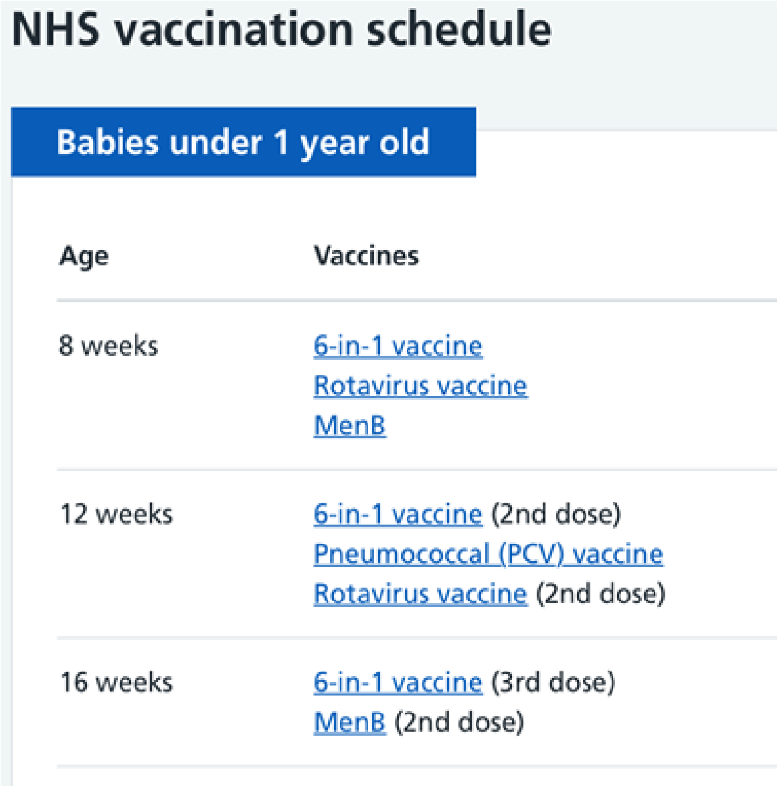

# Useful information

Sometimes it can be daunting as a new parent knowing what can be normal or not and when to worry if your child is unwell, the [Healthier Together website](https://www.swlondon-healthiertogether.nhs.uk/new-baby/worried-about-your-baby-whats-normal-and-whats-not) can be a helpful resource to support you.

## The ‘Baby Blues’

It is common for your mood to dip within the first weeks of having your baby. You might feel tearful, sensitive to criticism, irritable and even anxious. This can be worrying and often unexpected. In most cases, the symptoms last for only a few days as your body adjusts to the many changes that occur after giving birth. You can speak to your midwife or health visitor about this. We can also help, so please do not hesitate to book an appointment to discuss how you are feeling.

## Life as a new dad

Just like new mums, new dads may experience a low mood in the first year after birth. In addition to sleep deprivation and new responsibilities, you might be worried about your partner’s recovery, your new baby, finances and the prospect of changes to your relationship with your partner. This feeling is not uncommon. Book an appointment with us to talk about how we can support you.

## Talk Wandsworth

Talk Wandsworth offer free and confidential support. They run free virtual workshops that focus on Emotional Wellbeing For New Parents. To book your place, please visit Talk Wandsworth's [**website**](https://www.talkwandsworth.nhs.uk/index.php/wellbeing/wellbeing-workshops/maintaining-your-wellbeing-as-a-new-parent).

## Breastfeeding

If you are breastfeeding your baby and are finding it challenging or would like some advice, Wandsworth and Merton offer support through their **Infant Feeding Team, breastfeeding cafés**, or you can speak to your **community midwife**.

The Infant Feeding Team offer telephone or virtual appointments and are available Monday to Friday between 9am - 5pm on **07766800365** / **020 8725 0199** (answer phone) or via e-mail [**infant.feeding@stgeorges.nhs.uk**](mailto:infant.feeding@stgeorges.nhs.uk)

We encourage all new parents to read the leaflet **'Infant Feeding - Community Breastfeeding Support'** - it is available [**here**.](https://www.trevelyanhousesurgery.nhs.uk/wp-content/uploads/2022/05/Edited-Infant-Feeding.pdf)

There is also a digital tool from Start for Life called [The Breastfeeding Friend](https://www.nhs.uk/start-for-life/baby/feeding-your-baby/breastfeeding/breastfeeding-friend-from-start-for-life/#anchor-tabs), which also offers more practical information and advice on breastfeeding.

## Safe sleeping

It is important to know how to keep your baby safe when they are sleeping. This is to reduce the risk of sudden infant death syndrome (SIDS).

In summary, to reduce the risk of SIDS:

* place your baby on their back to sleep, this can be in a cot in the same room as you, for up to the first 6 months
* place your baby in the "feet to foot" position, with their feet at the end of the cot
* keep your baby's head uncovered – their blanket should be tucked in no higher than their armpits
* if wearing your baby in a sling or carrier, do not cover their head with the sling material or with a muslin
* do not let your baby get too hot or cold – try to keep the room temperature between 16 – 20°C
* do not share a bed with your baby – this is to avoid the risk of suffocation or overheating never sleep with your baby on a sofa or armchair do not smoke during pregnancy or breastfeeding, and do not let anyone smoke in the same room as your baby

The Lullaby Trust's leaflet **'Safer Sleep for babies'** is an excellent source of information and can be found [**here**.](https://www.lullabytrust.org.uk/wp-content/uploads/Safer-sleep-for-babies-a-guide-for-parents-web.pdf)

## Constipation

Constipation is a common problem often starting around the potty training stage but can also affect babies.

The ‘normal’ amount of bowel movements an infant passes varies depending on their age and what they are eating. Constipation can often occur when a baby starts eating solid foods (from 6 months old).

For more information on how to support constipation in your child please see [ERIC](https://eric.org.uk/childrens-bowels/constipation-in-children/) website and [Healthier Together](https://www.swlondon-healthiertogether.nhs.uk/professionals/gp-primary-care-staff/safety-netting-documents-parents/constipation) websites.

If you are worried that your newborn seems constipated, you can speak to your Health Visitor or book in with us at the GP surgery for more advice.

## Baby Buddy App

This app has been designed to help support new parents through their pregnancy and parenting journey, day by day.

You can download the **Baby Buddy** app by Best Beginnings from the Google Play Store and App Store by clicking the below.

